Electrocardiogram Data Capture and Manipulation for Measure of Cardiac Wellness

Thesis Proposal
For the degree of Master of Science in Computer Science
At Southern Connecticut State University

Jeff Becker

January 2010

Thesis Advisor: Dr. Hrvoje Podnar

Major-Field Approval – The advisor and the department chairperson
______________________ ____________________
Advisor Date
______________________ ____________________
Chairperson Date
A. Title
Electrocardiogram Data Capture and Manipulation for Measure of Cardiac Wellness
B. Statement of Purpose
An electrocardiogram (abbreviated EKG or ECG) records electrical impulses emitted by the heart through electrodes that are placed on specific points of the skin around the heart. These impulses are what cause the heart to expand and contract, which in turn pumps the blood. Researchers have used ECG machines extensively in order to determine the wellness of a patient's heart. From the data that the electrocardiogram collects, the muscular condition of the heart can be determined from abnormal rhythms. An electrocardiogram reading can show if the electrical impulse is normal or irregular, if the heart is too large or overworked, or if there is damage to the heart caused by a heart attack [6], [9]. A typical reading from an ECG is shown in Figure 1. 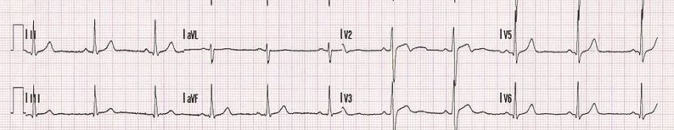
Figure 1: 12 Lead ECG of a 26-year-old male. [1]
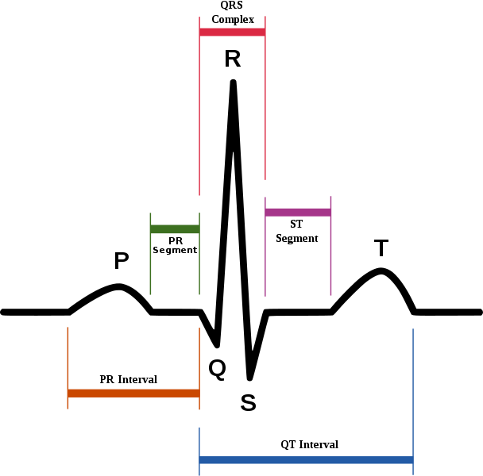
Figure 2 shows a representation of a single heartbeat.
Figure 2: Representation of a Single Heartbeat [1]
More specifically, the three points Q,R, and S show the heartbeat. The waves at P and T show how the arteries respond to the flow of blood. The time between the heartbeats can determine cardiovascular wellness. A normal heartbeat, when the patient is at rest, is called parasympathetic activity. When an outside factor causes the heart rate to rise, the increased heart rate is called sympathetic activity. After recording a patient's heart rate for several minutes, a standard deviation is taken. A high standard deviation indicates high parasympathetic nervous activity, which reveals that heart being in good health. Inversely, a low standard deviation indicates high sympathetic nervous activity, showing that heart being in poor health.
The proposed project will provide a user friendly system that will enable physicians to analyze ECGs in order to determine possible heart defects in an accurate and efficient manner. Specific attention will be applied to the distance between the peaks, represented by the letter R in Figure 2, as a function of time. Therefore, a doctor's diagnosis of a patient's heart condition can be quickly deduced.
C. Literature Review and Current State-Of-The-Art
Although recorded knowledge of bioelectricity was first observed by L. Galvani in 1787, it took approximately 86 years before the first ancestor of the electrocardiogram was created [11]. Gabriel Lippmann created what was called the capillary electrometer in 1873. Ingredients used in the electrometer were mercury with a small amount of sulfuric acid above the mercury. When an electrical pulse was detected, the mercury lept up a short distance. However, the first practical electrocardiogram that allowed recordings was created by Willem Einthoven in 1901 and was called a string galvanometer. A quartz string, hanging between two electromagnets would reflect a small electric current generated by the heart. The reflection was magnified through a metal plate onto a photographic film. Figure 3 depicts the string galvanometer.

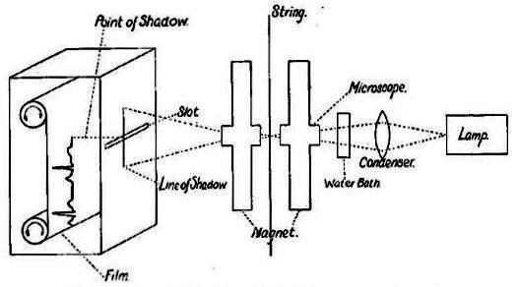
Figure 3: String Galvanometer
Currently, there are ECG monitoring systems that report data in real time and remotely. For example, GE's standard for remote electrocardiography is called Marquette Universal System for Electrocardiography or MUSE. MUSE is an ECG database management system that allows ECG data to be recorded via infrared or wireless technology from a compatible ECG machine, such as the GE MAC 5000 which is used in this project [3,8].
Another well received ECG system is by Monebo Technologies. Monebo Technologies has a device called a CardioBelt ECG Acquisition system which straps to a patient's chest and transmits data via Bluetooth to ECGAnalyzer monitoring software, which is then sent to a data monitoring center. This provides greater healthcare for patients from the comfort of their own home [7].
A similar project was attempted by Chaudary Zeeshan Arif [1] and colleagues who used wireless sensors placed on the skin to transfer the data via an 802.11b wireless signal. The results were significant because it demonstrated that wireless transmission of such important data was possible even though the data was inaccurate due to external interference.
With time, electronic devices have reduced in size and increased in accessibility. The electrocardiogram has evolved from the string galvanometer, a 600 pound machine that required 5 operators, to a pocket sized electrocardiogram that transmits data via Bluetooth to a cellular device as proposed by Ashraf Tahat [12]. The cellular device, or smart phone, will have software installed capable of accepting data from the ECG monitoring device by Bluetooth and transmit that data by means of the current cellular access technologies to a physician’s cell phone.
In a 2005 journal entry by Ricardo Baeza [13], it was stated that the Food and Drug Administration launched a program to collect and store all data collected from electrocardiograms from academic and commercial studies in a digital format. This will allow the FDA to assist on their analyses in the future. However, all electrocardiogram machines save collected data in their own vendor specific digital format, it would be difficult to standardize the data. Yet, all electrocardiogram machines produce standard paper records in either single or 12 lead formats [14]. Michael Laks et al. [14] developed a method to convert the printed ECG waveforms into voltage samples. For experimental purposes, the collected scanned raw data is transmitted over computer networks to a centralized reading location for expert cardiologists to compare the scanned data with the actual collected digital data to be compared. The results of this research showed that there were statistically no significant differences between the scanned and digital data, therefore suggesting a possible data standard to be used.
Currently, there is a website dedicated to finding an open source solution for electrocardiography [15]. The website was created by Dr. Ivor Kovic as a way to help hospitals and doctors who cannot afford commercial products. On the site, several EKG solutions are presented, including hardware and software. One such program called FreeECG, provides similar features as the proposed project, but does not calculate the Fast Fourier Transformation.
D. Research Plan
A program will be written in C++ using the Windows Audio Session API in order to receive and record data from an electrocardiogram machine through an analog to digital convertor. Tests will be performed to determine if a PC sound card can be used for this purpose. The recorded ECG data will then be measured along a time variable to display the heart rate of a patient. Meanwhile, the Fast Fourier Transformation will be calculated to display the sympathetic and parasympathetic heart rates of that patient. Data from the Fast Fourier Transformation can then be used to determine the cardiovascular health of a patient.
E. Methodology
In this project, Microsoft Visual Studio 2008 will be used to develop the C++ program. Microsoft's Visual C++ will used because it offers simple functionality with the sound card through the Windows Audio Session API (WASAPI). The WASAPI allows a simple but functional interaction from an audio endpoint device, such as a microphone. In this case, the endpoint device, rather than being a microphone, will be an electrocardiogram machine. Figure 4 shows a representation of the internal structure of the program.
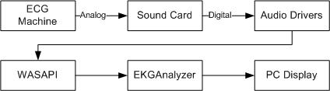
Figure 4: Internal structure of program
The electrocardiogram machine used in this project is located in the SCSU Health Sciences Laboratory. It is a GE MAC 5000 resting ECG analysis system. Located on the back of the MAC 5000 ECG is a 9 pin serial port as shown in figure 5.
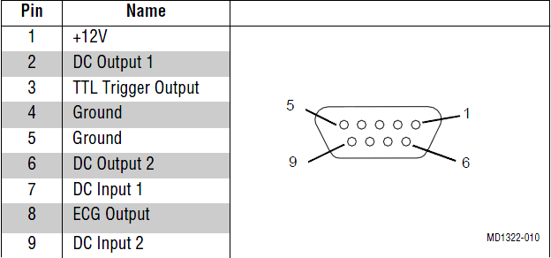
Figure 5: MAC 5000 output connector [3]
Pins 8 and 5 will be used to complete a circuit going to a microphone input of a computer sound card. The sound card being used is manufactured by Realtek Semiconductor Corp. Figure 6 shows a schematic of the proposed system. The computer's sound card will be used to convert the analog signals from the ECG machine into a digital format that will be analyzed and displayed in the proposed C++ program. Because the measured ECG signal is read in the millivolt range [2], it is well within the input capabilities of a standard PC sound card.
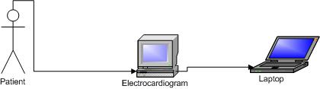
Figure 6: ECG program schematic
The application will display real time data streaming from the ECG machine. The Fast Fourier Transformation will be calculated and shown in a graph below the ECG output. The Fast Fourier Transformation will be calculated according to the recorded heart rate and will be shown in terms of the frequency. This will give a greater depiction of the difference between the parasympathetic and sympathetic activities.
The proposed software will include basic functions such as save, open, print and exit will be included in the menu as well as icons on the toolbar. There will also be three buttons, the first button to start recording data from the electrocardiogram machine, the second button to stop recording data from the electrocardiogram machine, and the third to quit the program. Two graphs will be drawn real time. The top graph will show the heart function while the bottom graph will show the calculated Fast Fourier Transformation graph. Looking at the Fast Fourier Transformation can be more informative than just the standard deviation alone. Figure 7 shows a sample of what the graphical user interface might look like with the Fast Fourier Transformation of an obese individual.
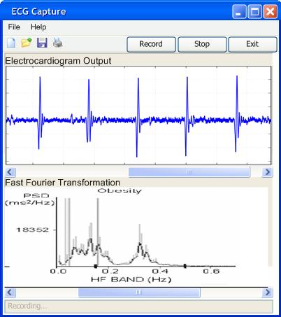
Figure 7: Graphical user interface
After ECG data capture is complete, the proposed system will enable users to run different types of analyzers. We propose to have a frequency analyzer, a peak difference analyzer, and an atrial repolarization/depolarization wave analyzer which shows when the blood enters/leaves the heart respectively. More analyzers will be considered and the system will be designed such that additional analyzing modules can easily extend the functionality to the proposed system. Figure 8 demonstrates the process of collecting the data and generating a report based on the measurements.
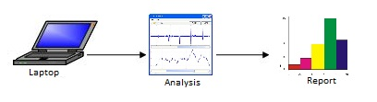
Figure 8: Analysis and Report of Collected Data
The Analysis and Reporting module is done to test a number of scientific hypotheses. Several hypotheses will be tested. One such hypothesis is of individuals who have tested positive for HIV will have increased sympathetic and reduced parasympathetic nervous activities, showing the negative effects that being HIV positive can have on the heart. Another hypothesis is of obese individuals. People who are obese have increased sympathetic and reduced parasympathetic activities, again showing the negative effects on the heart.
F. Contributions
The goal of this project is to develop an Open Source ECG monitoring and analysis system which will be readily available for free online download. Currently, ECG monitoring systems are proprietary and are provided by equipment manufacturers with a significant price tag.
In addition, as an Open Source system, our application can be easily expanded by development of suitable plug-ins such as the aforementioned analyzers. Such functionality makes it attractive to researchers.
Although the proposed project will be coded for the GE MAC 5000 electrocardiogram, it can be easily altered to capture data from any other ECG machine. In order to achieve this, a simple change in the adapter wiring is necessary.
References
[1] Arif, Chaudary Zeeshan, Patrick O. Bobbie, Hema Chaudhari, Sagar Pujari. Electocardiogram (EKG) Data Acquisition and Wireless Transmission. Marietta, Georgia: Southern Polytechnic State University.
[2] “Electrocardiogram,” Dec. 13, 2009. [Online]. Available: http://en.wikipedia.org/wiki/Ecg.
[3] GE Marquette Medical Systems, MAC 5000 Resting ECG Analysis System Field Service Manual, March 2000.
[4] GE Medical Systems Information Technologies, MAC 5000 Resting ECG Analysis System Operator's Manual. February 2003.
[5] Frigo, Matteo and Steven G. Johnson, FFTW, Massachusetts Institute of Technology, March 2009.
[6] Ohio State University Medical Center, Electrocardiogram (ECG or EKG), 2005.
[7] Monebo Marketing Team, Remote ECG Monitoring, Monebo Technologies, Inc., April 2008.
[8] GE Medical Systems Information Technologies, MUSE Cardiology Information System: Heart of the new MUSE Generation, General Electric Company, 2007.
[9] Milhorn, H. Thomas. Electrocardiography for the Family Physician: The Essentials. Boca Raton, Florida: BrownWalker Press, 2005.
[10] Homoud, Munther K., Introduction to Electrocardiography, Tufts-New England Medical Center, 2008.
[11] Zywietz, Chr., A Brief History of Electrocardiography: Progress Through Technology, Biosigna Institute for Biosignal Processing and Systems Research: Hannover, Germany.
[12] Tahat, Ashraf A., Mobile Messaging Services-Based Personal Electrocardiogram Monitoring System, Hindawi Publishing Corporation, 2009.
[13] Baeza, Ricardo, "Electrocardiogram digitization: a practical perspective on the usefulness of a new tool to convert paper electrocardiograms into digital waveform," Journal of Electrocardiography, Volume 38, Pages 321-323, 2005.
[14] Laks, Michael M., Suave M. Lobozinski, and Monika Kuzminska, Scan Conversion of Clinical Electrocardiograms, California State University, Long Beach, California, 2001.
[15] “OpenECGProject,”[Online]. Available: http://www.open-ecg-project.org/

